## Cape Town, South Africa: Black ANC Councillors Trash City Hall, Dance with Mock AK47s

Posted by [TNO Staff—](http://newobserveronline.com/author/administrator/) on March 9, 2014 [23 Comments](http://newobserveronline.com/cape-town-south-africa-black-anc-councillors-trash-city-hall-dance-with-mock-ak47s/#comments)

In yet another example of South Africa’s pitiful slide into Third World chaos, a recent Cape Town city council meeting meant to discuss that metropolis’s annual budget dissolved into chaos as African National Congress (ANC) councillors trashed the chamber while dancing, singing, and waving mock AK47s.

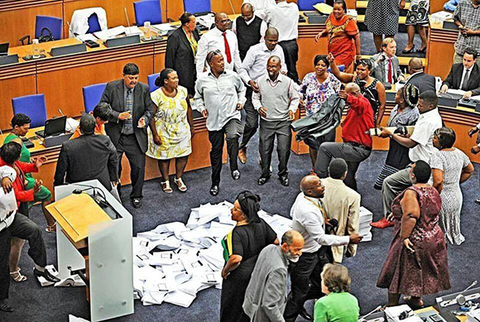

The ANC “protest” as they called it, was held in the council chamber of the only city of the country not controlled by South Africa’s ruling party.

In expressing their objection to the new budget—which dares to asks “consumers” to start actually paying for services such as electricity and other utilities (instead of making the—largely white—taxpayers of the city continue to pay for everything), the ANC councillors chanted slogans, banged on desks, dumped documents on the floor of the city council chamber, and then began dancing the “toyi-toyi” dance.

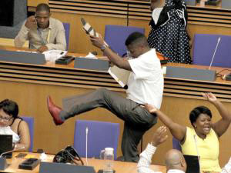

At least one ANC councillor, Kuthula Mamba, danced with a mock AK47, a weapon favored by the ANC during its war against the previous white government of the country.

The disruption lasted for hours after the ANC members refused to vote on the 2014/2015 draft budget, which has an operating budget of about R28 billion and a capital budget of just over R6 billion.

The budget proposed a 6 percent increase in rates, 7.6 percent for electricity, 8 percent for water and sanitation, and a 5.9 percent hike for solid waste.

Chanting and singing from the ANC benches continued and members later threw the draft budget documents onto the floor in the middle of the chamber, and then proceeded to dance around them in a circle.

The ANC is becoming increasingly radical as it attempts to fight off a serious challenge from the overtly anti-white “Economic Freedom Fighters” (EFF) party set up by former ANC youth leader Julius Malema.

The EFF has taken that part of the ANC’s original founding policy—which called for the nationalization of the mining industry and the banking sector—and combined it with a demand for the forced redistribution of land to the black peasantry, using Zimbabwe as the example to follow.

National elections are due in South Africa on May 7 this year.

<http://newobserveronline.com/cape-town-south-africa-black-anc-councillors-trash-city-hall-dance-with-mock-ak47s/>