Beyond Mourning

The sudden focus on Mandela's life casts South Africa’s current leaders in an unflattering light.
By Anne Applebaum
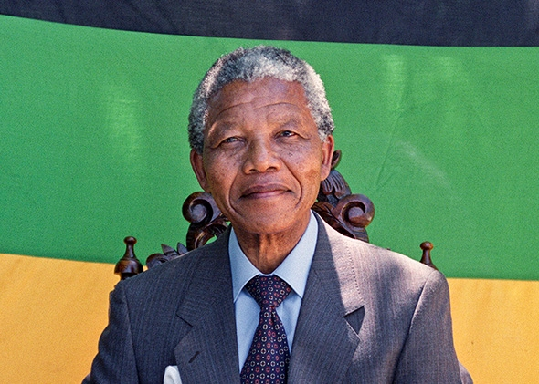Nelson Mandela smiles at his first press conference after his release from jail, on Feb. 12, 1990, in Cape Town.
Photo by Walter Dhladhla/AFP/Getty Images
LONDON—In Johannesburg a few months ago, I asked a young, black, and politically savvy South African journalist how his newspaper would cover Nelson Mandela's death. He shook his head: He dearly wished not to have to cover it at all. "I just hope I'm not in the office that day. I just hope I'm away, maybe in a different country."
He knew, of course, what Mandela's death would bring: a moment of national reckoning, an assessment of "what have we achieved" in the years since Mandela's release from prison in 1990 and his inauguration as South Africa's first black president in 1994. I told the young man that what was written in the wake of Mandela's death would probably reveal less about the man and more about his country. He agreed: That's exactly what he didn't want to have to face.
And that’s exactly what has happened. As my journalist colleague predicted, the world’s sudden focus on Mandela's life has already begun to cast South Africa’s current leaders in an unflattering light. "Mandela looms like a one-man Mount Rushmore over his successors," David Smith wrote for the Guardian, "throwing their flaws into sharp relief." The Economist, more bluntly, points out that "misguided governance, low-quality education, skills shortages and massive unemployment levels of around 40%" have made the black population of South Africa "more disadvantaged today than when Nelson Mandela was still behind bars."
This may only be the beginning. After all, without Mandela, the African National Congress—the party he first joined in 1943 and that he led to electoral victory half a century later—will quickly lose whatever remains of its revolutionary magic. Without Mandela, the ANC can no longer pretend to be a party, as he once put it, with a "noble cause": It is simply the party of power. Although South African democracy is extraordinarily healthy in many senses—its media, judiciary, and civil society function well—ANC candidates have until now won most national, and regional, elections by enormous margins. That means that people join the party in large numbers to get jobs, to get contracts, to get ahead.
In this narrow sense, the ANC now functions like the Chinese Communist Party: The most important political debates in South Africa take place within its ranks and at its congresses. Actual electoral contests matter much less. The consequences of 20 years of mostly one-party rule are the same for South Africa as they are in China: ANC-owned companies enjoy privileged access to state contracts, ANC politicians have been involved in complex cases of corruption, businesses often succeed or fail because of their political contacts and not because of their merit. Without real political competition, ANC politicians are not motivated to reform a state that still doles out patronage to black insiders, just as the apartheid state once reserved its jobs and contracts for whites. While in Johannesburg, I met a politician from the Democratic Alliance, the ANC’s most serious rival. He explained, convincingly, how his party has made big changes in the Western Cape, where it runs the regional government. But no one yet believes the party can win a national vote.
There are reasons why the ANC continues to win elections, legitimately, even while failing to deliver much in the way of economic growth to its supporters. So far, rival parties have failed to capture the national imagination, even if some have done well in some regions. So far, the ANC has persuaded black voters that they would be "outsiders," even traitors, if they voted for others. But Mandela's aura—the patina of history and glamour he lent to the party—were also part of the explanation. During its last elections, in 2009, one South African journalist wrote that it felt as though the ANC were still "overseen by a pantheon of deities, including Mandela."
During the long months of Mandela's illness, many in South Africa almost seemed offended by the idea that his death would bring some kind of radical change. He had, after all, been out of politics for a long time, and his greatest achievement—the peaceful transition to democratic rule—is not under threat. But although it might be uncomfortable, his death should cause South Africans to look critically at the state he helped create and, above all, at the ANC, the party he led. If South Africans really want to honor Mandela’s memory, they should deepen South Africa’s democracy, and vote for somebody else.

http://www.slate.com/articles/news_and_politics/foreigners/2013/12/nelson_mandela_and_the_anc_south_africa_needs_new_leaders.html

