Mandela received his first military training by Muslim Algerian terrorist group
Posted on December 7, 2013 by ADMIN6 Comments

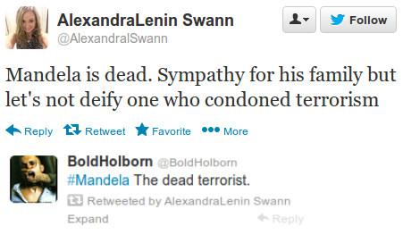
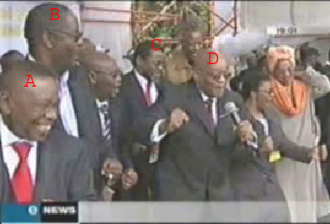
These are the top leaders of the ruling tricameral government in South Africa, Nelson Mandela’s ANC, singing ‘bring me my machine gun’ on national TV on Nov 6 2008. Machine gun for what? Killing “Boer’s” (whites). But they also ruthlessly gun down and kill blacks and Asians. Invented racial crimes are used to gather masses to attack and kill Boer’s. White Afrikaners are denied political asylum worldwide in spite of the warnings by Genocide Watch that they are targeted by genocide.
.
Nelson Mandela is a perfect example of media marketing where a terrorist is made into some kind of folk hero. Mandela did not fight for actual equality and freedom for all people. He fought for communism. He killed people, committed terrorism to force into power a communist government. The Algerian government has come out to admit Mandela as trained by terrorist group Algerian Liberation Army represented by The National Liberation Front (Jabhet Al-Tahrir Al-Watani) in 1961.
Like all extremist groups, they called their jihad ‘a fight for socialist nationalism’ and independence from French kafir presence in Algeria – which in their view was to demand Islamic law. Socialism to them and to us in the West have two different meaning. Freedom and democracy to Muslims mean Sharia law, more Islam. No wonder Mandela was fond of Muslim dictators and mass murderers, while he turned to Jewish people for monetary donations. NLF was an Algerian terrorist group responsible for several attacks on foreigners living in Algeria in the early 1990s.
While the Western world imagine Nelson Mandela was arrested by white people for ‘fighting for freedom’ the facts are something completely different. When Mandela was arrested, the following bombing materials were found on the farm where he stayed:
- 210,000 hand grenades
- 48,000 anti-personnel mines
- 1,500 time devices
- 144 tons of ammonium nitrate
- 21,6 tons of aluminium powder
- 1 ton of black powder
It was actually the whites in South Africa who voted out apartheid while Mandela was still in prison. Media says nothing about this truth. Nelson Mandela never put an end to it. Being lonely and isolated in prison he had to make friends with white people and learned to see that his prejudices had been generalized and one-sided.
By the time he got out of prison apartheid had already been disassembled. Although Nelson Mandela abandoned terrorism, which probably didn’t make his wife happy so she divorced him, he continued to be friends with brutal leaders. Mandela supported the “Palestinian” invasion and jihad of Israel and was a regular friend of brutal despots and dictators from Gaddaffi to Mugabe.
See pictures of Nelson Mandela’s ANC genocide and torture rampage taking place daily in South Africa.
.

Minister: Mandela received his first military training in Algeria
Staff writer, Al Arabiya News
Saturday, 7 December 2013
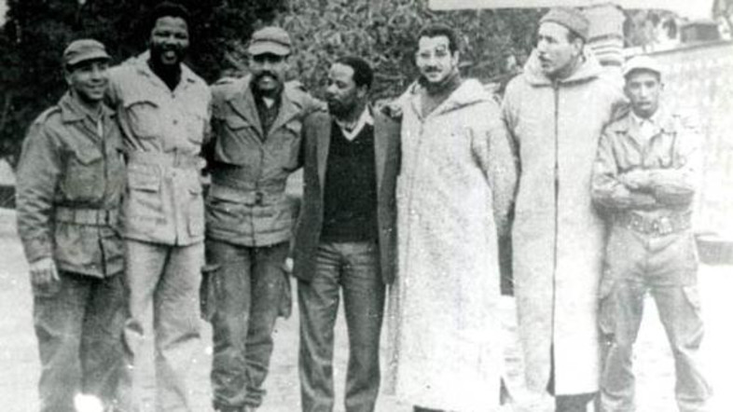
In 1961, Nelson Mandela visited the troops of the Algerian Liberation Army headquarters in the Moroccan city of Oujda. (Photo courtesy of http://www.sahistory.org.za)
While mourning the death of Nelson Mandela, an Algerian minister on Friday spoke of the African leader’s first military training in Algeria during 1960s.
“Mandela received his initial military training by the rebels of the National Liberation Front in Algeria in the early 1960s, when he decided to establish a military arm to the African National Congress,” Algerian Minister of Foreign Affairs Ramtane Lamamra told journalists during a summit for Peace and Security in Africa which began Friday in Paris.
“Algeria was a strong supporter of the African National Congress, providing it with weapons, passports and other tools which contributed to the historic triumph against apartheid,” Lamamra added.
In his autobiography “The Long Walk to Freedom,” Mandela admits that he was inspired by the Algerian revolution, which he said was the closest to South Africa’s at the time, writing “the Algerian rebels had to face a big colony of white men who were governing the majority of the population.”
In 1961, Mandela visited the troops of the Algerian Liberation Army headquarters in the Moroccan city of Oujda, where arms were frequently smuggled in to the Algerian rebels.
“They were an army of guerillas who earned their stars by the battles they fought, and they were more passionate about war and military strategies [jihad] than uniforms and parades,” Mandela wrote about the Algerian fighters.
“I knew that our forces are similar to most of the Algerian fighters, and was just hoping that they fight as bravely as them,” he noted.
Mandela also traveled to the mountains of Algeria where in 1961 he participated in a joint boot camp between the African National Congress fighters and the Algerian National Liberation Army.
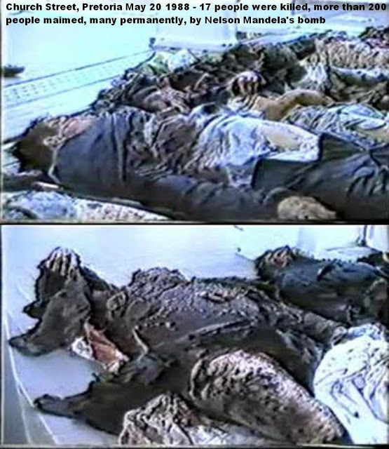
Click on image (below) to enlarge to watch Nelson Mandela’s murders:
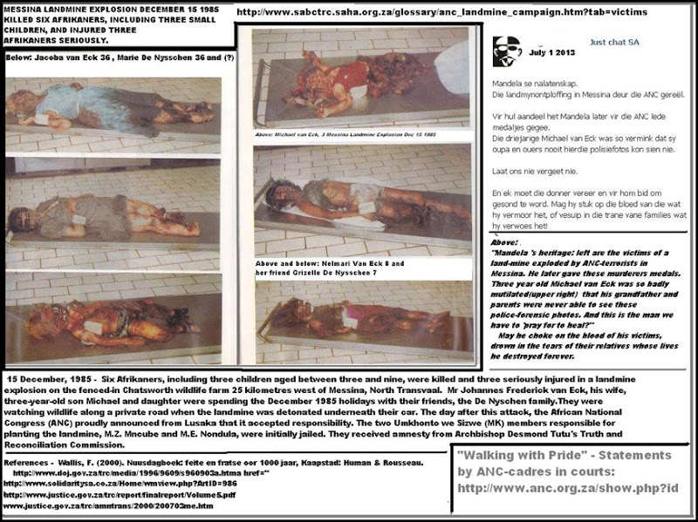

Political support
Mandela was inspired by the Algerian rebels and they in turn encouraged him to pursue his fight for freedom. In his book, Mandela quoted the representative of the interim Algerian government in Morocco, Shawqi Mustafa’I as saying: “Don’t neglect the political side of the war while organizing the armed forces, especially when international opinion is sometimes worth more than a fleet of jetfighters.”
Since 1965, Algeria has hosted many fighters from the African National Congress, who received military training before returning to South Africa to execute military operations.
Following Mandela’s death, Algerian President Abdul Aziz Boutefliqa ordered that the Algerian flags be flown at half-mast for 8 days in honor and respect “of this glorious African personality.”
Boutefliqa called Mandela “the loyal friend of Algeria.”
Algeria was the first country Mandela visited after his widely celebrated release from prison in Feb. 1990 as a symbolic gesture showing appreciation for Algeria’s support to the people of South Africa during its struggle against the apartheid.
Last Update: Saturday, 7 December 2013 KSA 01:35 – GMT 22:35
https://themuslimissue.wordpress.com/2013/12/07/mandela-received-his-first-military-training-by-algerian-terrorist-group/

