Mandela’s double talk and support of evil
Mandela was flawed human being, full of contradictions and shortcomings, a man who alternately extolled violence and reconciliation.
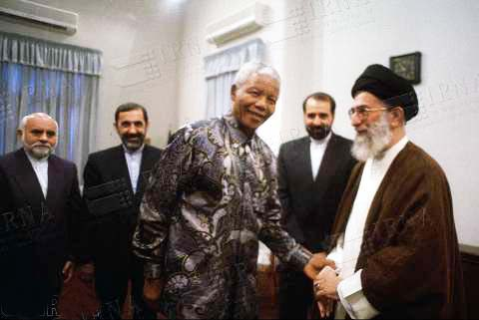
Nelson Mandela displayed public support of the totalitarian Ayatollah regime.
Imagine a person who planned acts of sabotage and incited violence, resulting in the deaths of innocent civilians and damage to public property.
A man who embraced brutal dictators throughout the Third World, such as Libya’s Gaddafi and Cuba’s Castro, singing their praises and defending them publicly even as they trampled on the rights and lives of their own people.
A person who hugged Yasser Arafat at the height of the intifada, hailed Puerto Rican terrorists who shot US Congressmen, and penned a book entitled, How to be a good Communist.
Picture all this and, believe it or not, you will be staring at a portrait of Nelson Mandela.
The death of the South African statesman last week has elicited an outpouring of tributes around the world, with various leaders and media outlets vying to outdo one another in their praise of the man.
Highlighting his principled stand against apartheid, and his firm determination to erect a new, post-racial and color-blind South Africa, many observers have hailed Mandela in glowing terms, as though he were a saint free of blemish and clean of sin.
But such accolades not only miss the mark, they distort history in a dangerous and damaging way and betray the legacy of Mandela himself.
Take, for example, the editorial in The Dallas Morning News, which likened Mandela to Moses and labeled him “the conscience of the world.”
And then there was Peter Oborne, the UK Telegraph’s chief political commentator, who wrote a piece entitled, “Few human beings can be compared to Jesus Christ. Nelson Mandela was one.”
Source: Jerusalem Post
My comment:
The truth about Nelson Mandela is painful. Surely he was a victim of racism, and lead a much needed revolution. But he never stopped supporting evildoers outside of his own country.
As a former communist, he hailed Fidel Castro. Mandela also embraced Islamic terrorists Yasser Arafat, and the secular anti-Zionist movement And because of the USA history of imperialism in Persia, Mandela offered his blessings to the Ayatollah of Iran.
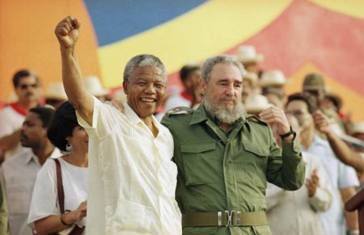
The two communist leaders never stopped supporting each other.
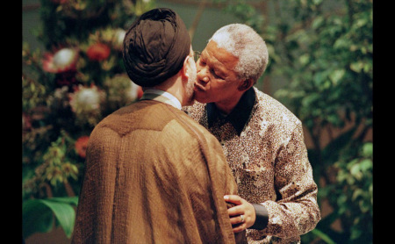
President Mandela always had a deep love for the Iranian leaders.
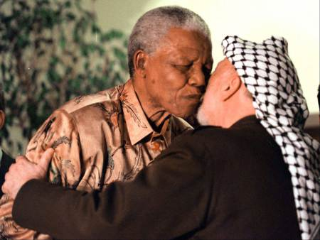
The ANC leader also supported the PLO and Islamic terrorism against Israel.
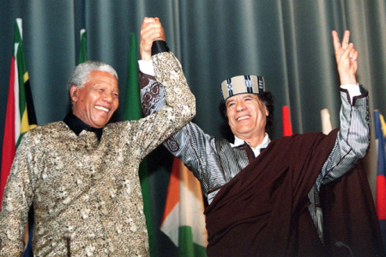
Mandela did not mind Gaddafi killing his own people.
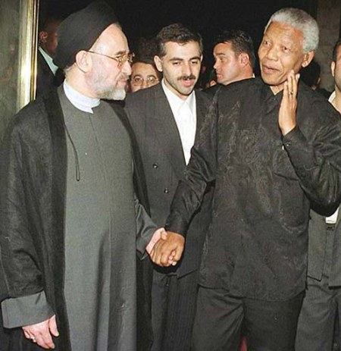
Nelson Mandela hand in hand with former Iranian president Muhammed Kanthami.
Today, a rainbow movement of global “peace makers” are ready to whitewash all these criminals. The ideology is that “love” covers a multitude of sins, and if we stand united we can overcome.
The problem with such a gospel of works, is that the blood of Jesus is rejected. Man can not find true peace, without surrender to the prince of peace, the Messiah.
So be wise. Do not put your trust in the new universal brotherhood of men, but Accept the Lordship of Jesus of Nazareth.
Written by Ivar
http://ivarfjeld.com/2013/12/11/mandelas-double-talk-and-support-of-evil/

