The Mandela Cover-up Unravels
Cliff Kincaid — December 8, 2013

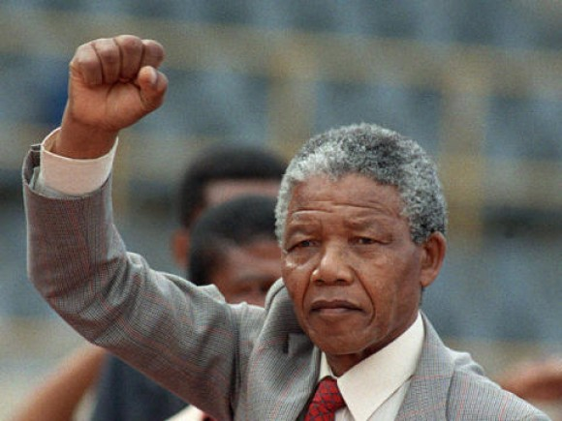

0

It appears that AIM and blogger Trevor Loudon are among the few sources highlighting the official statement of the South African Communist Party (SACP) about Nelson Mandela having been a high-ranking member. SACP deputy general secretary Solly Mapaila is quoted by a South African magazine as saying it was denied at the time for “political reasons.”
The communist Workers World Party, which supports North Korea, has also reprintedthe official SACP statement about Mandela. The communists are proud of Mandela and what he accomplished. His false claims of being a non-communist fooled South Africa and the world (except for his domestic and international comrades who were in on the secret). The official SACP statement includes these words: “At his arrest in August 1962, Nelson Mandela was not only a member of the then underground South African Communist Party, but was also a member of our Party’s Central Committee.”
Politicians lie, but this was a whopper, designed for the purpose of turning South Africa and its strategic materials over to the communists. The perfect front man, Mandela had always denied being a party member and, for the benefit of foreign audiences, publicly rejected Marxism as a “foreign ideology” as recently as a few years ago. It appears that was just a ploy to keep the foreign aid coming. South Africa has been among the top ten recipients of U.S. foreign aid, getting close to $500 million in fiscal year 2013.
Now that we know what’s going on, what will we do about it? Three American presidents—Obama, Clinton, and George W. Bush—are going to South Africa for his state funeral on December 15. Obama has ordered American flags to remain at half-staff in his honor until sunset on December 9. The con will continue. Still, the facts matter.
Many in the media are calling Mandela a “political prisoner” when he served prison time. But on the Fox News “Special Report” show on December 5, Jesse Jackson admitted Mandela told him that he was planning bombings of hospitals and schools in South Africa when he got caught. That is why Mandela went to prison. He ran Umkhonto we Sizwe, the terrorist wing of the African National Congress (ANC) and South African Communist Party. The white minority made a deal to release him because they feared for their lives against a Soviet-sponsored terrorist onslaught that was documented in 1982 Senate hearings entitled “The Role of the Soviet Union, Cuba, and East Germany in Fomenting Terrorism in Southern Africa.”
One of the witnesses before those hearings was Bartholomew Hlapane, a member of the African National Congress’s national executive committee and the South African Communist Party’s central committee. Bartholemew, who described SACP domination of the ANC, was assassinated in his home in South Africa on December 16, 1982, by an Umkhonto we Sizwe assassination squad. The ANC lateradmitted to the crime.
President Obama condemned the Boston Islamic terror bombings, saying, “Any time bombs are used to target innocent civilians it is an act of terror.” But that is what Mandela was orchestrating in South Africa. And Mandela is Obama’s role model. Apparently, it was okay to kill whites in the name of black majority rule.
So how is that working out for the blacks, the supposed beneficiaries of Mandela’s revolution?
WikiLeaks is usually a source that our media trust. But little attention was paid to information from WikiLeaks demonstrating that the South African government is now resorting to “forced removals, violence, [and] intimidation” against poor blacks demanding their rights. Referring to a group of black shack dwellers known by the initials AbM, the U.S. embassy cable from 2010 said: “While the ANC claims to be making efforts to clean up slums and provide the poor with adequate housing, AbM leadership claims intimidation and anti-democratic tactics are used against its members by the ruling party.”
It’s true that Mandela failed to authorize a bloodbath of the minority whites once the black majority took power. But that decision recognizes, as the Chinese communists did, that socialism doesn’t work. The whites had to be tolerated because of their economic expertise. However, whites are now getting killed regularly in the “new” South Africa, and the country is being featured on “Genocide Watch” because of the racist dangers there. A spin-off from the ruling African National Congress, the Economic Freedom Fighter (EFF) movement, held a rally in October in South Africa featuring banners saying the “Honeymoon is over for white people in South Africa.” The group is openly Marxist-Leninist.
Interestingly, a column in the far-left Huffington Post hints at the truth, noting that Mandela “spent much of his life as a radical Marxist allied with global communist luminaries…”
In addition to the evidence of Mandela’s secret membership in the Communist Party, those “global communist luminaries” deserve some attention. He admired Fidel Castro, praised his “brother in arms” Yasser Arafat, and was a big fan of Libya’s Muammar Gaddafi. He was awarded the Soviet Union’s International Lenin Peace Prize. Russian President Vladimir Putin congratulated Nelson Mandela on his 95th birthday in July and “gave a high assessment to Nelson Mandela’s role in developing friendly Russian-South African relations, which have now reached the level of a strategic partnership.” Indeed, Russia and South Africa have become strategic partners in the BRICS group. BRICS refers to Brazil, Russia, India, China and South Africa.
An objective source of some of Mandela’s famous quotations is the book, In the Words of Nelson Mandela, edited by Jennifer Crwys-Williams. They include:
- “Islam has enriched and become part of Africa; in turn, Islam was transformed and Africa became part of it.”
- “The people of Libya shared the trenches with us in our struggle for freedom.” (Spoken at a banquet in Tripoli, Libya in 1997).
- “He [Muammar Gaddafi] helped us at a time when we were all alone, when those who are now saying we should not come here were helping our enemies.” (Spoken at the start of his 1997 trip to Libya).
- “My brother leader.” (referring to Gaddafi).
Gaddafi was the terrorist leader who killed 189 Americans, most of them college students, by bombing Pan Am 103. The year was 1988. Gaddafi was also behind the La Belle bombing in Berlin in April of 1986. This killed two Americans and a Turkish woman and injured well over 200 persons, including 41 Americans.
In a story about the 1997 visit to Libya, The New York Times noted: “Although Mr. Mandela had twice visited Libya before, this is his first trip since becoming President [of South Africa] in 1994. No Western leader has visited Libya since the sanctions were imposed after Colonel Qaddafi refused to turn over suspects in the 1988 bombing of Pan Am Flight 103 over Lockerbie, Scotland.”
But Mandela was thankful Gaddafi gave his terrorist movement weapons. He didn’t care about the terrorism that took American lives. Later, Gaddafi renounced terrorism, paid restitution to the families of Pan Am 103 victims, and gave up his own nuclear program. Nevertheless, Obama authorized his overthrow and he was killed by a mob in Libya.
Bill O’Reilly said on his Fox News show that Mandela “was a communist, all right? But he was a great man. What he did for his people was stunning. … He was a great man, but he was a communist.” Throwing out the word, without documenting it, leaves people without adequate information and O’Reilly vulnerable to the tired charge of “McCarthyism.”
The notion of a good communist, considering the bloody history of the movement, seems absurd. But sadly, that is some of the best coverage of Mandela that we have seen.
The left’s hero worship of Mandela—as well as of Obama—is to be expected. Strangely, similar coverage came from Breitbart News Senior Editor-at-Large Joel Pollak, who claimed Mandela “embraced constraints on his power,” was a George Washington-type figure, a friend of Israel, opposed terrorism, and “did not turn his back on the United States and her ideals.” He went on Mark Levin’s radio show to repeat some of these dubious, and even ridiculous, claims.
Pollak quoted Mandela during his treason trial as saying, “I have cherished the ideal of a democratic and free society in which all persons live together in harmony and with equal opportunities.” Mandela also declared at the time that he was not a communist.
Now we know better. Or do we?
http://www.aim.org/aim-column/the-mandela-cover-up-unravels/

